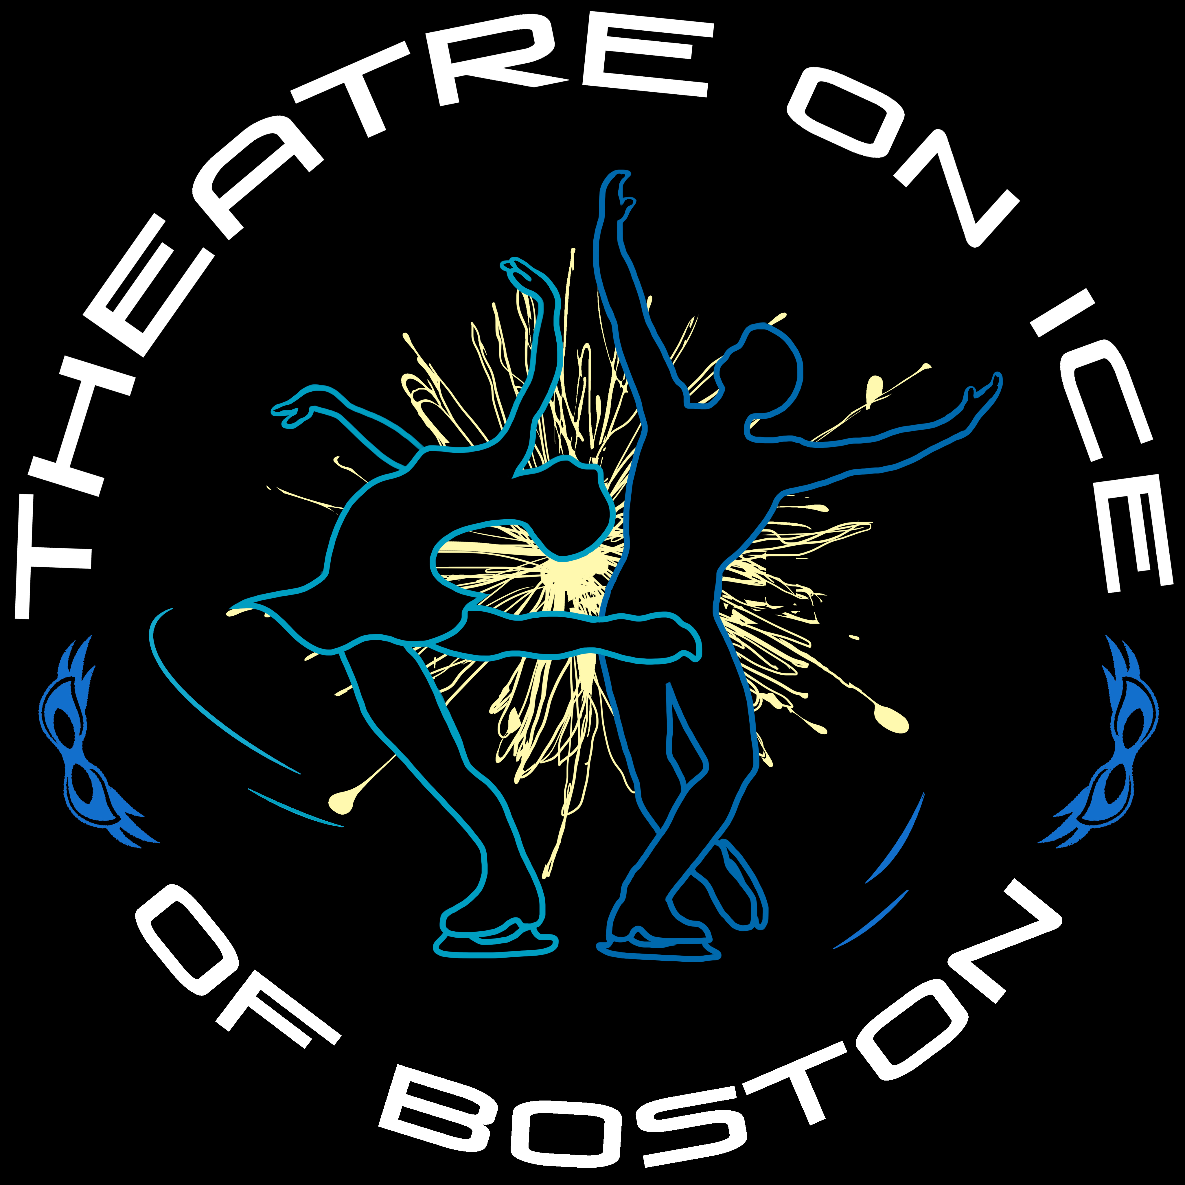

Saturday, March 5th – The Rivers School – Weston, MA

8:00-8:30 Welcome, National Anthem & Exhibition
8:30-9:00 Family Skate time with Skate Lap Challenge
9:00-9:30 More Exhibition & So You Think You Can Skate Contest (Interpretative)
930-9:50 On Ice Games Shoot the Duck, crazy spins, & elements competition
9:50-10:00 Ice Make
10:00-11:00 Exhibition – Guest Stars and other skaters!
11:00-11:30 Family Skate with Skate Lap Challenge

